Question 1.

(a)

图示

AI 生成的内容可能不正确。

(b)

文本

AI 生成的内容可能不正确。

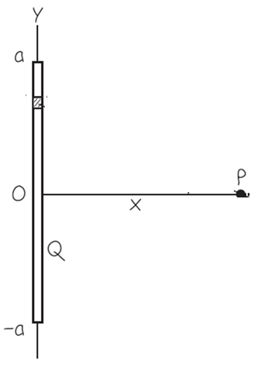

(c) 手机屏幕截图

AI 生成的内容可能不正确。

图示

AI 生成的内容可能不正确。

Question 2.

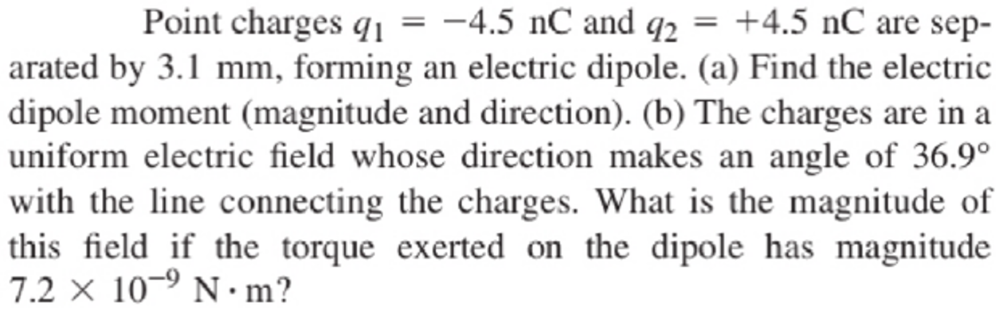

Question 3.

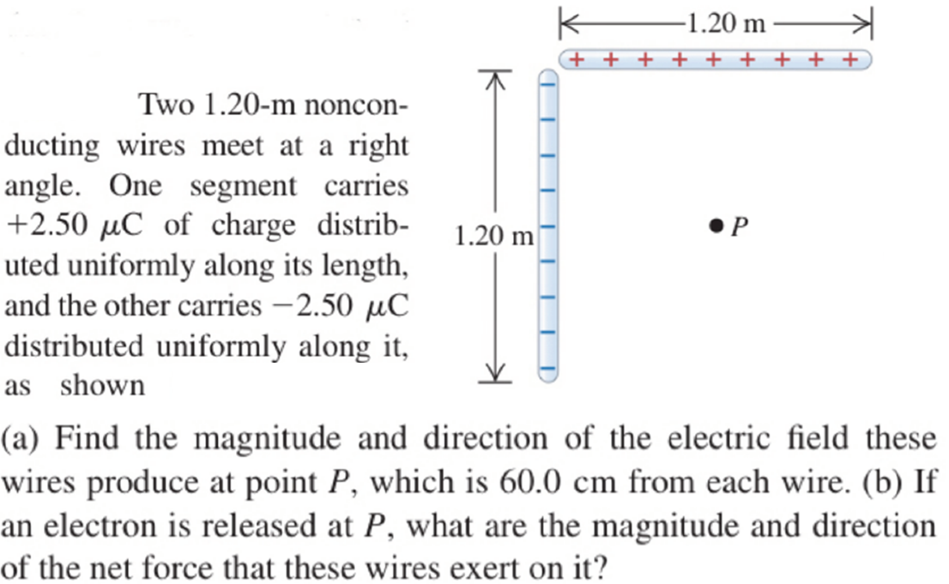

Question 4.

1. Electric charge is distributed uniformly along an infinitely long, thin wire. The charge per unit length is λ (assumed positive). Find the electric field using Gauss’s law.
2. Use Gauss’s law to find the electric field E caused by a thin, flat, infinite sheet with a uniform positive surface charge density σ.

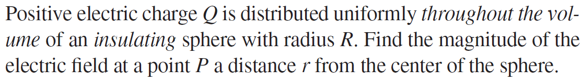

图示, 示意图

AI 生成的内容可能不正确。

(d) A spherical conductor has a radius of 0.04 m. On the surface an amount of charge is evenly distributed with a surface charge density of σ = 6.5 nC/m2. What is the strength of the electric field at the surface of this conductor?

Question 5. A solid conductor with three cavities carries a total charge of +7 nC. Within the first cavity, insulated from the conductor, is a point charge of -5 nC. Within the second cavity, insulated from the conductor, is a point charge of 6 nC. Within the third cavity, insulated from the conductor, is a point charge of 8 nC. (a) How much charge is on each surface (inner and outer) of the conductor? (b) What is the electric field flux across a closed surface that encloses the conductor entirely? (c) What is the electric field flux across a closed surface within cavity 1 that encloses the first charge of (-5 nC)?

Question 6. Two charged q1 and q2 separated by 2*a* are both at a distance of *a*/2 from an infinitely long line charge (charge per unit length λ). Another charge q0 moves from A to B (the middle point between q1 and q2) as depicted by the figure. (a) What is the change of potential energy of the system by the process? (b) What is the electrostatic force experienced by the charge q0 at position A? (c) What is the electrostatic force experienced by the charge q0 at position B? Express your answer in terms of λ, *a*, q0, q1 and q2 and needed constants.

手机屏幕的截图

AI 生成的内容可能不正确。

Question 7.

Two concentric spherical conducting shells are separated by vacuum. The inner shell has total charge +Q and outer radius ra and the outer shell has charge -Q and inner radius rb. Find the capacitance of this spherical capacitor.

Question 8.

文本, 信件

AI 生成的内容可能不正确。

卡通人物

AI 生成的内容可能不正确。

Question 9

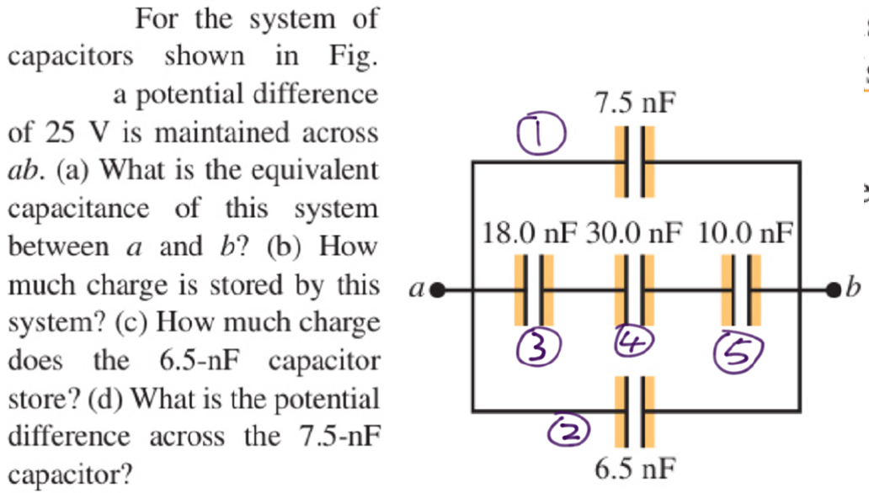

Question 10. Suppose the parallel plates each have an area of 2000 cm2 and are 1.0 cm apart. We connect the capacitor to a power supply, charge it to a potential difference V0 = 5.0 kV and disconnect the power supply. We then insert a sheet of insulating plastic material between the plates, completely filling the space between them. We find that the potential difference decreases to 1.00 kV while the charge on each capacitor plate remains constant. Find (a) the original capacitance C0 (b) the magnitude of charge Q on each plate; (c) the capacitance C after the dielectric is inserted; (d ) the magnitude of the induced charge Qi on each face of the dielectric; (e) the electric field E after the dielectric is inserted. (e) Find the energy stored in the electric field of the capacitor and energy density, before and after the dielectric sheet is inserted.

Question 11. An 18-gauge copper wire (the size usually used for lamp cords), with a diameter of 1.02 mm carries a constant current of 1.67 A to a 200-W lamp. The free-electron density in the wire is 8.5×1028 per cubic meter. Find (a) the current density and (b) the drift speed. (c) If we heat up the copper wire, will the current density decrease or increase? Explain why.   
If the wire has a cross-sectional area of 8.20 × 10-7 m2. Find (d) the electric-field magnitude in the wire; (e) the potential difference between two points in the wire 50.0 m apart; (f) the resistance of a 50.0-m length of this wire

Question 12.

